**Project Report: Criminal Activities in India**

**Introduction**

The purpose of this project is to analyze criminal activities in India using various datasets from Kaggle. We perform exploratory data analysis (EDA), data cleaning, and visualization to derive insights and answer specific questions. Additionally, we create interactive dashboards to facilitate better understanding and communication of the findings.

**Datasets**

The project utilizes the following datasets:

1. Crime Against Women
2. Children
3. Murders Cases
4. Victims of Murder
5. Kidnapping and Abduction
6. Violent Crimes
7. IPC Crimes in City
8. IPC Crimes in States
9. Total Complaints Received

**Data Analysis and EDA**

The analysis involved multiple steps, including data loading, cleaning, and exploratory analysis to uncover insights.

**Data Loading and Cleaning**

Each dataset was loaded and cleaned to ensure consistency and accuracy. This included handling missing values, correcting data types, and standardizing categorical values.

**EDA and Insights**

For each dataset, we explored various aspects to answer key questions.

**1. Crime Against Women**

**Questions and Insights:**

1. **How many States and UTs are in the Dataset?**
   * There are 28 states and 8 UTs in the dataset.
2. **What are the numbers of crimes in 2019, 2020, and 2021?**
   * The numbers of crimes against women in 2019, 2020, and 2021 are **405326**, **371503**, and **428278** respectively.
   * **Uttar** **Pradesh** has the most Crime against women in 2019 -> 59853, 2020 -> 49385 and also in 2021 -> 56083
3. **Which states have the highest number of crimes against women?**
   * Top 5 states with the highest crimes rates:

|  |  |
| --- | --- |
| * + - 1. **Assam** | **168.3** |
| * + - 1. **Delhi** | **147.6** |
| * + - 1. **Odisha** | **137.8** |
| * + - 1. **Haryana** | **119.7** |
| * + - 1. **Telangana** | **11.2** |

1. **Which states have the lowest number of crimes against women?**

* Bottom 5 states with the lowest crimes:

|  |  |  |
| --- | --- | --- |
| 1 | **Nagaland** | **5.1** |
| 2 | **Ladakh** | **13.8** |
| 3 | **Puducherry** | **18.5** |
| 4 | **Manipur** | **19.1** |
| 5 | **Gujrat** | **22.1** |

1. **Are crimes against women increasing or decreasing?**

From 2019 to 2020, the change is

* highest increased in Crime against women in West Bengal 22.03%
* highest decreased in crime against women in Lakshadweep -60.52%

From 2020 to 2021, the change is

* + highest increased in Crime against women in D&N haveli & Daman Diu 62.29%
  + highest decreased in crime against women in Lakshadweep -40.0%
  + crime against women is decreasing year by year in Lakshadweep

1. **What is the distribution of crime rates across different states?**
   * Distribution analysis shows that [Uttar Pradesh] has the highest rate, and [Lakshadweep] has the lowest rate.

**2. Crime against Children**

1. **Questions and Insights: How many States and UTs are in the Dataset?**
   * There are 28 states and 8 UTs in the dataset.
2. **What are the numbers of crimes in 2019, 2020, and 2021?**
   * The numbers of crimes against Children in 2019, 2020, and 2021 are 148090, 128531, and 149404 respectively.
3. **Which States have most crimes against children?**
   * States have the most Crime against children in

Maharashtra in 2019 -> 19592,

Madhya Pradesh in 2020 -> 17008

Madhya Pradesh in 2021 -> 19173

1. **Which states have the highest number of crimes against women?**
   * Top 5 states with the highest crimes rates:

|  |  |  |
| --- | --- | --- |
| 1 | Delhi | 128.5 |
| 2 | A&N Islands | 110.4 |
| 3 | Lakshadweep | 85.4 |
| 4 | Sikkim | 72.4 |
| 5 | Chandigarh | 72.2 |

1. **Which states have the lowest number of crimes against women?**

* Bottom 5 states with the lowest crimes:

|  |  |  |
| --- | --- | --- |
| **1** | **Ladakh** | **1.2** |
| **s** | **Nagaland** | **6.2** |
| **3** | **Jharkhand** | **13.5** |
| **4** | **Manipur** | **13.8** |
| **5** | **Bihar** | **14.5** |

1. **Are crimes against Children increasing or decreasing?**

* A/c to 2019 to 2020:
  + 1. highest increased in Crime against Children in West Bengal 65.53%
    2. ii) highest decreased in crime against Children in Lakshadweep -65.38%
* A/c to 2020 to 2021:

i) highest increased in Crime against Children in Lakshadweep 88.8%

ii) highest decreased in crime against v in Ladakh -50.0%

crime against Children after covid i.e., in 2021 has jumped up in almost states & UTs.

**3. Murders Cases**

**Questions and Insights:**

1. **Total number of murder cases in each year?**
   * 2019: 28915
   * 2020: 29198
   * 2021: 29272
2. **Top 5 states with the highest murder cases?**

|  |  |  |
| --- | --- | --- |
| 1 | Jharkhand | 4.1 |
| 2 | A&N Island | 4.0 |
| 3 | Haryana | 3.8 |
| 4 | Chhattisgarh | 3.4 |
| 5 | Assam | 3.4 |

1. **States vs UTs distribution of murder victims?**
   * States: 18.38%,
   * UTs: 81.62%
2. **Regions with the highest increase in murder cases?**
   * Uttar Pradesh has the most Murder Crime in 2019 -> 3808, 2020 -> 3779 and also in 2021 -> 3717
3. **Measure the murder cases Crime Numbers are increased or decreased?**

* A/c to 2019 to 2020:
  + 1. highest increased in Murder Crime in Puducherry 34.48%
    2. highest decreased in Murder crime in A&N Island -61.53%
* A/c to 2020 to 2021:
  + 1. highest increased in Murder Crime in A&N Island 220.0%
    2. highest decreased in Murder crime in Puducherry -51.28%

**4. Victims of Murder**

**Questions and Insights:**

1. **Age distribution of murder victims?**

* Adult: 95.35%, Child: 4.65%

1. **Gender-wise analysis of murder victims?**
   * Male: 43434, Female: 16810, Trans: 20
2. **Top 5 states with the highest number of murder victims?**

|  |  |  |
| --- | --- | --- |
| 1 | UP | 7650 |
| 2 | Bihar | 5652 |
| 3 | Maharashtra | 4762 |
| 4 | Madhya Pradesh | 4180 |
| 5 | West Bengal | 3838 |

1. **Analysis of victims Age Distributions?**

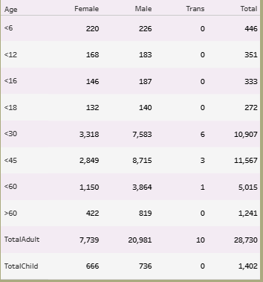

**5. Kidnapping and Abduction**

**Questions and Insights:**

1. **Number of kidnapping cases in each year?**

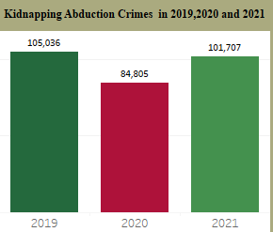

1. **States with the highest kidnapping rates?**

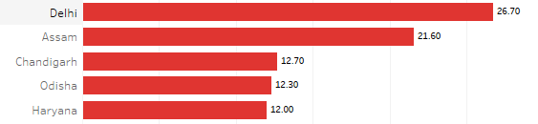

1. **States with lowest kidnapping rates?**

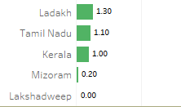

1. **Which States have the most Kidnapping Abduction Crimes?**

* Most kidnapping Abduction Crime in 2019 -> 18590 ,2020 -> 17913& 2021 ->14554 each in Uttar Pradesh

1. **Measure the Kidnapping Abduction Crime Numbers are increased or decreased?**

* A/c to 2019 to 2020:
  + 1. highest increased in Crime against Children in Puducherry 111.11%, West Bengal 79.36%
    2. highest decreased in crime against Children in A&N Island -74.04%, Nagaland -62.50%
* A/c to 2020 to 2021:

1. highest increased in Crime against Children in D&N Haveli and Daman & Diu 128.57%, Puducherry 110.52%, Nagaland 100.0%
2. highest decreased in crime against v in Lakshadweep -100.0%

**6. Violent Crimes**

**Questions and Insights:**

1. **Total number of violent crimes in each year?**

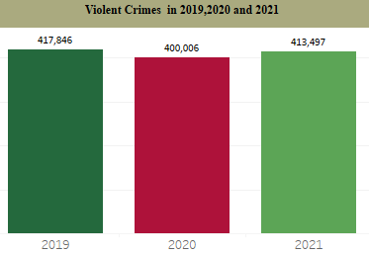

1. **States with the highest violent crime rates?**

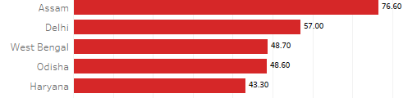

1. **States with the lowest violent crime rates?**

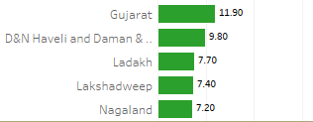

1. **Regions with the highest increase in violent crimes?**

* A/c to 2019 to 2020:
  + 1. highest increased in violent crime in Puducherry 47.94%
    2. highest decreased in violent crime in Lakshadweep -68.72%
* A/c to 2020 to 2021:

1. highest increased in violent crime in Ladakh 283.3, D&N haveli & Daman Diu 41.55%
2. highest decreased in violent crime in Kerala -17.450%
3. **States vs UTs distribution violent crimes?**

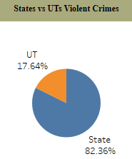

**7. IPC Crimes in City**

**Questions and Insights:**

1. **Total IPC crimes in cities each year?**

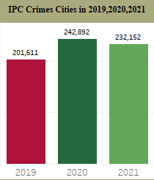

1. **Top cities with the highest IPC crime rates?**

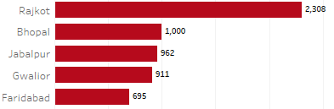

1. **Cities with the lowest IPC crime rates?**

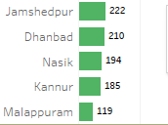

1. **Most IPC Crime in Indian Cities are**

2019 -> Thiruvananthapuram --> 22248

2020 -> Rajkot --> 24140

1. -> Rajkot -> 32104
2. **Measure the IPC City Crimes Numbers are increased or decreased?**

* **A/c to 2019 to 2020:**
  + 1. highest increased in IPC City Crime in Rajkot 984.45%, Madurai 343.36%, Tiruchirappalli 204.06%
    2. highest decreased in IPC City Crime in Thiruvananthapuram -46.68%, Nasik -22.97%, Jodhpur -22.86%
* **A/c to 2020 to 2021:**

1. highest increased in IPC City Crime in Kannur 144.48%, Jabalpur 40.11%, Rajkot 32.99%
2. highest decreased in IPC City Crime in Tiruchirappalli -64.12%, Madurai -61.24%, Thiruvananthapuram -51.88%

**8. IPC Crimes in States**

**Questions and Insights:**

1. **Total IPC crimes in states each year?**

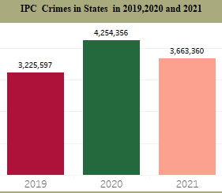

1. **Top states with the highest IPC crime rates?**

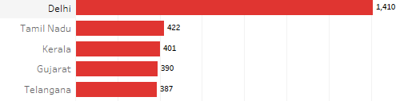

1. **States with the lowest IPC crime rates?**

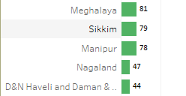

1. **The Most Number of IPC Crime States in India 2019, 2020 and also in 2021**

* 2019 -> Uttar Pradesh 353131
* 2020 -> Tamil Nadu 891700
* 2021 -> Maharashtra 367218.

**9.Total Complaints Received**

**Questions and Insights:**

1. **Total number of complaints received?**

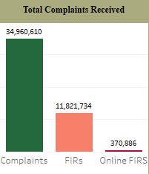

1. **Types of complaints most common?**

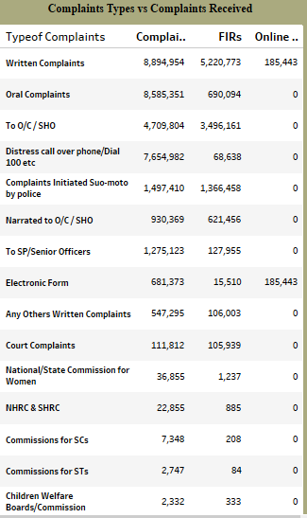

**Data Cleaning Steps**

1. **Handling Missing Values**: Identified and filled or removed missing values.
2. **Correcting Data Types**: Ensured all columns had appropriate data types.
3. **Standardizing Categorical Values**: Standardized categorical values for consistency.
4. **Removing Duplicates**: Identified and removed duplicate records.

**Data Visualization**

Using Tableau, we created interactive dashboards for each dataset to visualize:

1. **Crime Trends Over Years**: Line charts showing trends.
2. **Crime Distribution by State/Region**: Bar charts and heat maps.
3. **Gender Distribution in Crimes**: Pie charts and bar charts.
4. **Age Distribution of Victims**: Histograms and bar charts.
5. **Types of Crimes**: Pie charts and bar charts.

**Dashboard Highlights**

1. **Crime Against Women Dashboard**: Showcases the trend, distribution, and types of crimes against women.
2. **Children Crimes Dashboard**: Highlights the states with the highest and lowest crimes, and types of crimes.
3. **Murder Cases Dashboard**: Visualizes the distribution of murder cases by age, gender, and region.
4. **Victims of Murder Dashboard**: Detailed analysis of victim demographics.
5. **Kidnapping and Abduction Dashboard**: Trends, distribution, and demographic analysis.
6. **Violent Crimes Dashboard**: Overview of violent crimes by type and region.
7. **IPC Crimes in City Dashboard**: Crime rates and types in different cities.
8. **IPC Crimes in States Dashboard**: State-wise analysis of IPC crimes.
9. **Total Complaints Received Dashboard**: Overview of complaints received over the years and types of complaints.

**Conclusion**

This project provided valuable insights into the nature and distribution of criminal activities in India. The data analysis and visualizations help in understanding trends, identifying hotspots, and formulating strategies for crime prevention and control.

**Next Steps**

* **Further Analysis**: Deep dive into specific crime types for more granular insights.
* **Predictive Modeling**: Build models to predict future crime trends.
* **Policy Recommendations**: Use insights to suggest policy changes for crime reduction.

**Appendix**

* **Code Snippets**: Detailed code used for data analysis and visualization.
* **Data Dictionary**: Explanation of each dataset's columns and values.
* **References**: Kaggle datasets and other sources used.